Data structures

Inbuilt DS: List, tuples, set, dict.

User defined DS:

Two types: Simple, Compound

Simple🡪 List/Array

Array is nothing but a list in python with same datatype.

Array index starts from 0.

|  |  |  |  |  |  |  |  |  |
| --- | --- | --- | --- | --- | --- | --- | --- | --- |
| 1 | 2 |  |  |  |  |  |  |  |

i---one variable is enough.

|  |  |  |  |  |  |  |
| --- | --- | --- | --- | --- | --- | --- |
| 1,1 | 1,2 | 1,3 | 1,4 | …… |  |  |
| 2,1 | 2,2 | 2,3 | 2,4 | ….. |  |  |

Row =I starts 1

Column=j start 1

Array can be one dimensional, two dimensional, multi dimensional;

Array is same as list..

Single dimensional array:

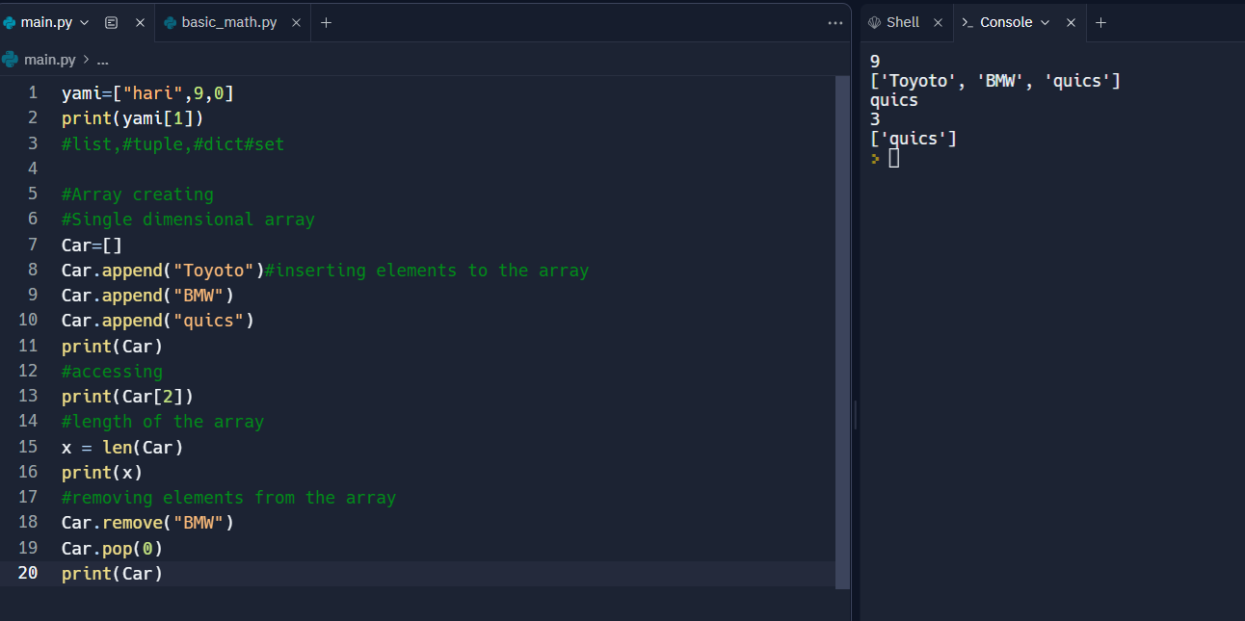

Multidimensional array:/LIST OF LISTS

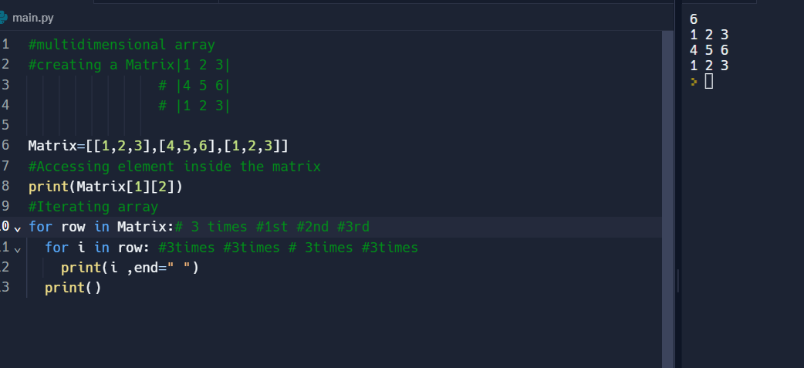

#Enumerate function:

|  |  |  |
| --- | --- | --- |
| 1 | 2 | 3 |
| 4 | 5 | 6 |
| 7 | 5 | 9 |

|  |
| --- |
| I=0 |
| I=1 |
| I=2 |

|  |  |  |
| --- | --- | --- |
| R=0 | R=1 | R=2 |

for i, row in enumerate(Matrix):

if i == 2:

row[1] = 5

STACKS:

LIF0///last in first out.---FILO---first in last out.

Operations in stack:

Push---input-------(TOP)

Pop-del/output---(TOP)

PEEK/TOP----------(TOP)

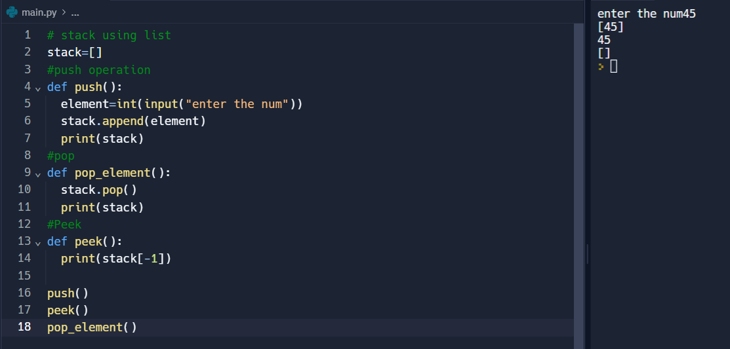

#Stack using list

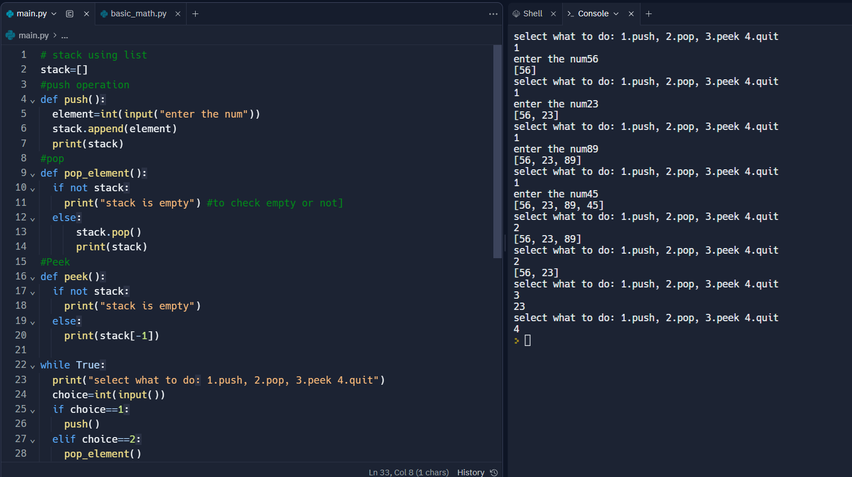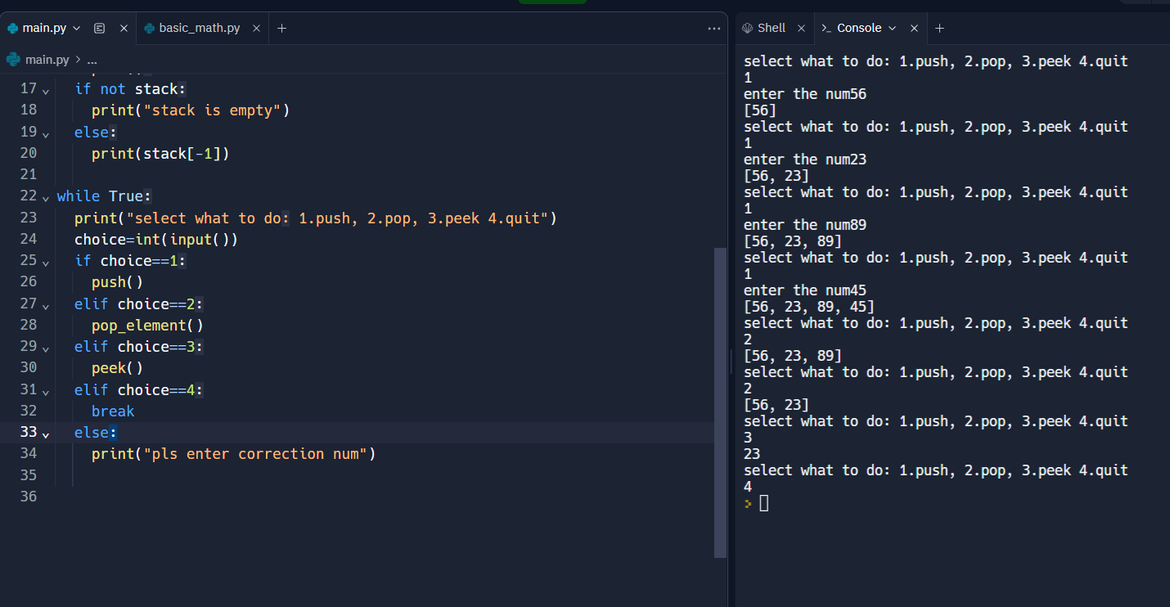

#stack using modules

